COMP 5047: Team Part
The group implemented an agile approach for this project, with collaboration supported through weekly meetings. Each members focused on completing their own assigned tasks for their subsystem, while regular meetings allowed the team to stay on track with deadlines. This allowed flexibility for individual work whilst ensuring completion of tasks on time. One member was appointed as group leader to support coordination and encourage consistent communication and contribution within group members. The group leader was responsible for organising meetings, tracking any progress, and reminding members of upcoming tasks and their deadlines. The agile methodology was applied through short development cycles for individual coursework tasks, supported by formal documentation of system requirements and modelling activities. Weekly meetings were used to address any issues encountered by group members, answer questions, review individual progress, and coordinate the integration of the subsystems.

Diagram 4.1: Architecture of the whole system
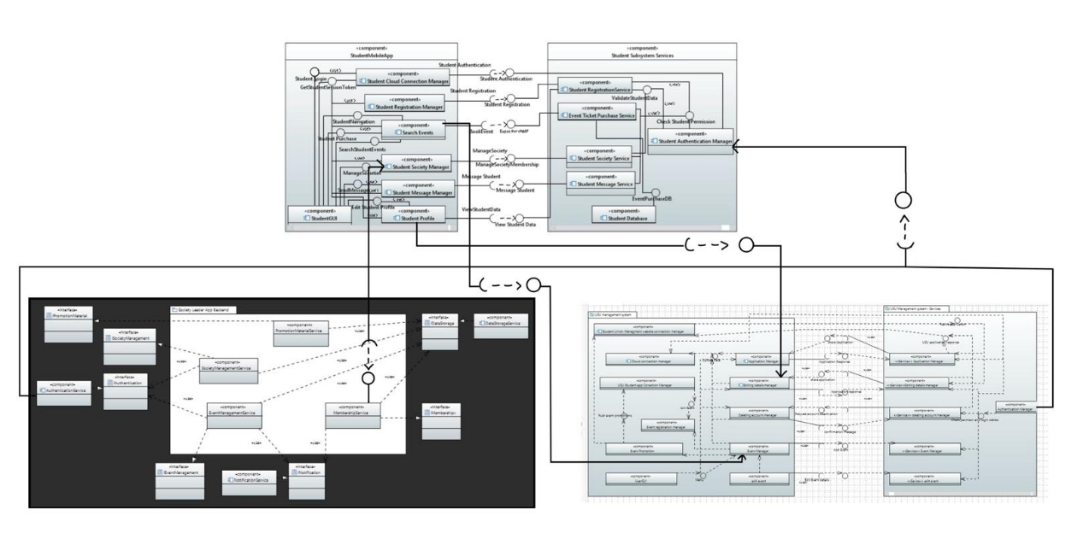
Diagram 4.2 shows the integration architecture of three subsystems: USU Student App, Society Leader App, and USU operation system. The solution implemented by the group consisted on preserving all components and interfaces from the subsystems, while having an unique name. This enables each subsystem to operate on its own without any problems regarding duplicate interface or component names. The connections demonstrate where subsystems require specific functionalities from each other while maintaining their ability to function independently. The following are the connections found in the system’s architecture:
Membership Service (from Society Leader App Backend) → Student Society Manager (in StudentMobileApp)
Search Events (from StudentMobileApp) → Event Manager (from USU Management Service)
Student Profile (StudentMobileApp) → Editing Details Manager (from USU Management Service)
Authentication Service (Society Leader App Backend) and Authentication Manager (from USU Management Service) → Student Authentication Manager

